Theoretical aspects of visual modeling

Jaroslav Prochazka

Department of Informatics and Computers, University of Ostrava

Abstract: Nowadays, we can meet computers even in fields where it was not usual and in all these disciplines we can meet with visual models. They allow user simpler control and more user friendly environment for programming, setting up and using computing systems than the textual one. Since visual models describe system instructions or operations, they need precise notation and meaning definition for all their elements. The objective of this paper is to clarify some notions, especially syntax and semantics. We explain why are they important, why we need their precise definition and clarify distinction between them.

Keywords: visual modeling, syntax, semantics, language, tools.

1. INTRODUCTION

Because of information technology (IT) expansion in the last several decades, we can meet computers even in fields where it was not usual (e.g. automation, machine tool control: NC and CNC, e-learning). There exist also whole new branches based on information technologies or bound up with IT, for example software engineering, computer control or biotechnology field. In all these disciplines we can meet visual models. These are not only useful in software development (SW is essential for running computing systems) but also in every day work. Visual models allow user simpler control and more user friendly environment for programming, setting up and using computing systems (control, embedded or computer) than the textual one. User do not have to remember a lot of commands and see all settings or changes generally viewed by some graph or tree. Since visual models describe system (machine) instructions or operations or are applied for control and embedded system programming, they need precise notation and meaning definition for all their elements and components. These words are, not only in IT world, known as syntax (notation) and semantics (meaning).

It is obvious that modeling is one of the most
important aspect in computing systems, but we have to say that visual modeling is not a silver bullet. It is not suitable for everything and it is not a nostrum. There exists some arguments against diagrams, see e.g. Brooks (1987).

In my doctoral thesis I deal with suitable application logic visual modeling for generating executable code. Thought approach is to generate code, at least its snippets, directly from process description. While designing visual modeling tool it is important to know objectives of syntax and semantics, what is the distinction and what are they useful for.

The objective of this paper is then clarify some notions in visual modeling field especially syntax and semantics. We explain why are they important, why we need their precise definition and clarify distinction between them. We also discuss language representation – textual and visual. The last part deals with diagrams and models which are applicable for application logic, process and algorithm modeling.

1.1 Modeling

The purpose of science is to describe and understand complex systems, such as a system of atoms or society of human beings, Bruegge (2000). We distinguish between natural sciences and social sciences. Natural sciences deals with nature and its subsystems. The purpose of social sciences is to understand human beings. There is also another type of system that we call an artificial system. These includes stock trading systems, airline reservation systems etc. For this science is coined the term sciences of the artificial. Many methods that have been successfully applied in the natural sciences and humanities can be applied to the sciences of the artificial as well. One of the basic methods of science is modeling. A model is an abstract representation of a system that enables us to answer questions about system. Models are useful when dealing with systems that are too large, too small, too complicated or too expensive. Models also allow us to visualize and understand systems that either no longer exist or that are only claimed to exist. System modelers deal with two types of entities: the real-world system (observed in terms of a set of phenomena) and the problem domain concept (represented as a set of interdependent concepts).

Complex systems are generally described by more than one model, each focusing on a different aspect or level of accuracy. Modeling means constructing an abstraction of a system that focuses on interesting aspects and ignores irrelevant details. What is interesting or irrelevant varied with the task at hand. Generally, modeling focuses on building a model that is simple enough for a person to gasp completely. A rule of thumb is that each entity should contain at most 7+-2 parts as discussed by Miller (1956).

Since modeling is very extensive domain, we come up only with one other notion. This notion is view. A view focuses on a subset of a model to make it understandable. This paper is promoted by research intention MSM 6198898701 and by internal grant IGA 03/2005.

1.2 Visual programming

Let us briefly introduce visual programming. The primary advantage of visual programming languages is that they provide direct representations of software structures such as algorithms and data. This is in contrast to traditional textual programming languages, where are these structures encoded into one-dimensional strings according to some complicated syntax. Visual languages remove this layer of abstraction, allowing the programmer to directly observe and manipulate complex software structures. While some software development systems fully address the visualization of algorithms, there are many that provide visual representations of data and processes in specific domains. One obvious example is the tools some development systems provide for building graphical user interfaces and other common application parts. These tools usually consist of a library of classes that implement the functionality of the domain (e.g. windows, menus), together with WYSIWYG editors for viewing and manipulating concrete representations of instances of these classes. Some of these systems also provide some visual programming capability directed specifically at the target domain: for example, message-flow programming, which is well suited to the kinds of interactions that occur between interface elements or between interface elements and data repositories, Cox (1998).

Visual programming is used also in control systems field. Interesting example is one for robot control, see Cox (1998). In this example is visual programming used for defining robot, his behaviour, and his environment using two modules: hardware definition module and software definition module. For both these modules has to be strict syntax and semantics defined.

2. LANGUAGE SYNTAX AND SEMANTICS

Language syntax is called notation of its elements and relations. Meaning of each legal element is called semantics. There is general agreement in the literature that data is used to communicate and needs an interpretation to extract the information behind it , Harel (2000). An interpretation is always a mapping assigning a meaning to each (legal) piece of data. The two notions are often mixed up, thus becoming a major source of confusion. On the one hand, the same piece of information may be encoded in a variety of pieces of data, for example:

„May 31st, 2005“
and
„the last day of may of the fifth summer in the second millennium“

denote the same day, although in very different ways. On the other hand, the same piece of data may have several meanings and may therefore denote different information for different people or for different applications. We thus distinguish between syntax and semantics. Partners to communication must first agree on their communication language, which fixes the set of data that can be communicated. A language consists of a syntactic notation (syntax), which is a possibly infinite set of elements that can be used in the communication, together with their meaning (semantics). We often denote a language by L, see following figure 1.

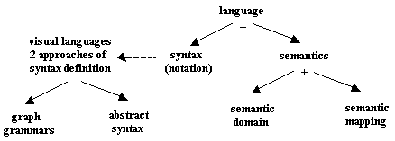
Fig. 1. Language structure.

Various terms are used for the syntactic elements in different kinds of languages, words, sentences, statements, diagrams, terms, models, clauses, modules, etc. Language semantics consists of two parts: a semantic domain, which we denote generically by S, and a semantic mapping from the syntax to the semantic domain, denoted by M.

Let us introduce example:

<exp> = <number> ⏐ <variable>
⏐ (<exp>)
⏐ <exp> [ + ⏐ – ⏐ * ⏐ / ] <exp>

then sense of mathematical expression n*(n+1) / n defined by these language in whole number domain would be a number. So we use N (whole number set) as semantics domain S of <expression>. The semantic mapping would thus associate a number with each expression of the language, formally:

M: <expression> → N

Given a syntax L and a semantic domain S, the final step in defining a semantics is to relate the syntactic concepts to those of the semantic domain. Each syntactic creature is mapped to some semantic element.

M: L → S

Whereas for textual languages the use of grammars for the syntax is widely accepted, for diagrammatic languages there exist two competing approaches, as shown on figure 1. On the one hand, we have graph grammars, that extend the grammatical ideas from textual languages to diagrams, and they have indeed been applied to significant parts of the UML. On the other hand, we can use the abstract syntax of a diagrammatic language.

2.1 Visual programming

Abstract syntax of a picture (diagram) is defined [Er97] as:

(V, E, s, d, μ, $μ$)
such that V and E are disjoint sets of vertices and edges (collectively called graph objects) and
s, d : E → V
map an edge to its respective start or destination vertex.
μ : (E ∪ V) x A → U A is the set of attributed names, U the set of all possible attribute values.
$μ$ : A → U
The set of all attributed graphs for a given A and U is written as $Γ$(A, U).

Formality of a semantic definition depends on the way the syntax, the semantic domain and the semantic mapping are represented. A fully formal semantic definition includes an explicit formal definition of the semantic mapping. Semantic mappings is possible to define using examples only, but it does not make a satisfactory semantics. For example it does not allow machine analysis of the mappings.

2.2 Representation

All of these elements so far discussed, need to be denoted by appropriate notations. Rigorous and readable mechanisms are necessary in order to define and represent these elements appropriately. For conventional textual languages the syntax is described by a set of characters (called the alphabet) and the sequences of characters that are legal. We will typically first group characters into words and then arrange words into sentences according to precise grammatical rules. The language then consists of the set of all these legal sentences.

As to diagrams, there is different way of viewing their syntax. We do not need to draw a diagram as starting with lines or line-segments and then making boxes and arcs out of them. Rather, we have layers of topological notions, that are then specialized using geometry, then put together topologically, and then specialized once again using geometry. Here is how this might go (Harel and Rumpe, 2000):
- The first layer consists of two kinds of basic topological elements – open line segments and closed ones.
- These are specialized geometrically to several kinds of lines (arrows, straight lines and splines all with various line styles and colors), and closed shapes, boxes, circles, also with various line styles and colors.
- The geometric shapes are arranged into diagrams by first making topologically meaningful combinations of them (using connectivity, insideness and intersection), and then arranging these geometrically into an actual two or three dimensional diagram.
- The fourth layer yields the set of legal diagrams by imposing context condition.

Similarity between some models and mathematical structures is discussed by Prochazka (2005).

3. APPLICATION LOGIC MODELING TOOLS

We will discuss some tools suitable for modeling application logic (or algorithms) and for generating source code. OMG´s architecture MDA talks about and uses executable UML – it should bring UML specification 2.0. So we will start with some UML models suitable for modeling application logic. Further, we briefly introduce powerful and complex tool called Petri nets and Jackson Structured Diagrams known from Jackson development process.

Modeling application logic is not so easy, we need to catch all objects concerning with process, describe its behaviour, depict parallelism. For all these stuffs should tool have not only notation.

3.1 UML diagrams

UML contains two diagrams which are suitable for modeling behaviour: an activity diagram (see fig. 2) and a sequence diagram. Activity diagram can be used for modeling logic as a collection of activities and for modeling business processes as well. Activity diagram consists of actions, transitions and branches.
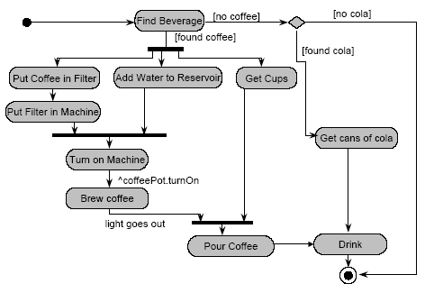
Fig. 2. Activity Diagram

There exists also notation for parallelism. It is possible to model two or more branches, which should run parallel including its continuity.

The second diagram suitable for application logic modeling is called a sequence diagram. Sequence diagrams describe interactions among objects during the time. These diagrams focus on objects and the messages they exchange to accomplish some desired behavior, but have worth means for chronological representation.

3.2 Petri nets

Petri net is an automat, which defines the behaviour of system using event sequences and corresponding system state changes. This tool is also used for parallel and distributed system analysis, design and modeling.
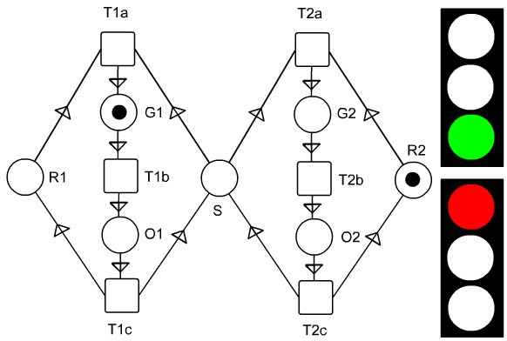
Fig. 3. Petri net for two traffic lights.

Fig. 3 shows Petri net for two traffic lights, where is not allowed to signal green at the same time. Petri net consists of places (circles), which can contain token (state information), transitions (cubes), which implies possible state changes and oriented arcs showing logical binding.

3.3 Jackson Structured Diagram

The last tool we will mention is Jackson structured diagram. It is similar to Structure charts, but has additional expressive power for sequence, selection and iteration. Following diagram (Fig. 4) denotes: Task 1 consists of Task 2, 3 and 4 in said order.
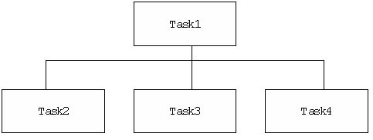
Fig. 4. Jackson Structured Diagram

There exist other tools suitable for modeling application logic, e.g. ASM (Abstract State Machines) or Hierarchical state machines. But their description is out of range of this paper.

4. CONCLUSIONS

We explained syntax and semantics concepts and showed the main sources of confusion. Syntax says what pieces can we use and semantics shows their meaning. Now is clear, that every tool designer or user have to be familiarized with these theoretical aspects. In the second part we introduced some visual tools for modeling application logic.

REFERENCES

[1] Brooks, F. P. Jr. (1987). No Silver Bullet: Essence and Accidents of Software Engineering. Computer. Vol. 20. No. 4. pp. 10-19.
[2] Bruegge, B., Dutoit, A., H. (1997). Object oriented software engineering. Prentice Hall. ISBN 0130471100.
[3] Miller, G. A. (1956). The magical number seven, plus or minus two. Psychological Rev. Vol. 63.
[4] Harel, D. and Rumpe, B. (2000). Modeling languages: syntax, semantics and all that stuff. In Technical Report MGS00-16. Weizmann Science Press of Israel.
[5] Erwig, M. (1997). Abstract visual syntax. In. Proc. 13th IEEE Symposium on visual languages. pp. 15-25.
[6] Procházka, J. (2005). Visual models syntax and semantics and structures similarity. In. Proc. 3mi Conference. Dolní Lomná.
[7] Cox, P. T. and Smedley, T. J. (1998). Visual programming for robot control. In. Proceedings of IEEE Visual Languages Symposium. Halifax.

